
Dashboard Design

Date | 31 October 2026
Team ID | Not applicable – Individual Project
Project Name | EV Market Performance & Insights
Maximum Marks | 5 Marks

Creating an effective dashboard involves thoughtful design to ensure that the presented information is clear, relevant, and easily understandable for the intended audience. Here are some key principles and best practices for dashboard design
Activity 1: Interactive and visually appealing dashboards
Creating interactive and visually appealing dashboards involves a combination of thoughtful design, effective use of visual elements, and the incorporation of interactive features. Here are some tips to help you design dashboards that are both visually appealing and engaging for users so take care of below points
- Clear and Intuitive Layout
The dashboard uses a project title, KPI cards at the top, a year-wise trend and supporting market comparison charts. Keep chart titles and KPI labels readable.
- Use Appropriate Visualizations
A line chart shows yearly sales; bar charts compare vehicle categories, battery technologies and countries; a map shows geographic distribution; a pie chart compares manufacturers; a scatter plot compares average price and rating.
- Colour and Theming
The supplied dashboard uses a consistent blue chart style, with distinct colours in the manufacturer pie chart and scatter plot to distinguish marks.
- Interactive Filters and Slicers
A Year filter is visible on the dashboard screenshot. Verify that it filters the intended worksheets before submission.
- Drill-Down Capabilities
No separate drill-down hierarchy is clearly evidenced in the supplied screenshot. Do not claim this feature unless configured and tested.
- Responsive Design
The dashboard is arranged for Tableau Public. Check the published view on the target screen size and adjust sizing if any charts are clipped.
- Custom Visuals and Icons
The project uses standard Tableau charts and a geographic map. No custom icon set is evident in the screenshot.
- Use of Infographics
The KPI cards and Story captions provide a compact summary of the main market observations.

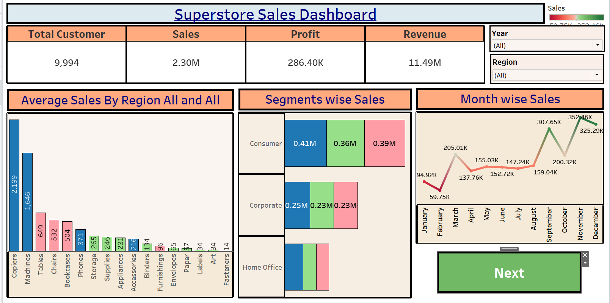
Note: Highlight the major outcomes in form of bullet points

Activity 2
Publish Dashboard on Tableau Public and Paste the Dashboard Public link below:
Example
https://public.tableau.com/views/SalesDashboard_17247660582000/Dashboard1?:language=en-US&publish=yes&:sid=&:redirect=auth&:display_count=n&:origin=viz_share_link

Major Outcomes from the EV Dashboard
• The KPI cards display Total EV Sales of 832,000, Average Driving Range of 480.6 km and Average Rating of 4.325.
• The year-wise sales chart rises from 400,000 in 2021 to 968,000 in 2025 in the values shown.
• The vehicle-category chart shows SUV higher than Sedan in the visible comparison.
• The battery technology chart shows NMC sales higher than LFP.
• The country chart compares China, France, Germany, India, Japan, South Korea and the USA.
• The geographic map provides a spatial view of EV sales by country.
• The manufacturer pie chart compares BYD, Ford, Hyundai, Nissan, Renault, Tata Motors, Tesla and Volkswagen.
• The scatter plot compares average vehicle price with average customer rating across manufacturer marks.

Dashboard Screenshot Evidence
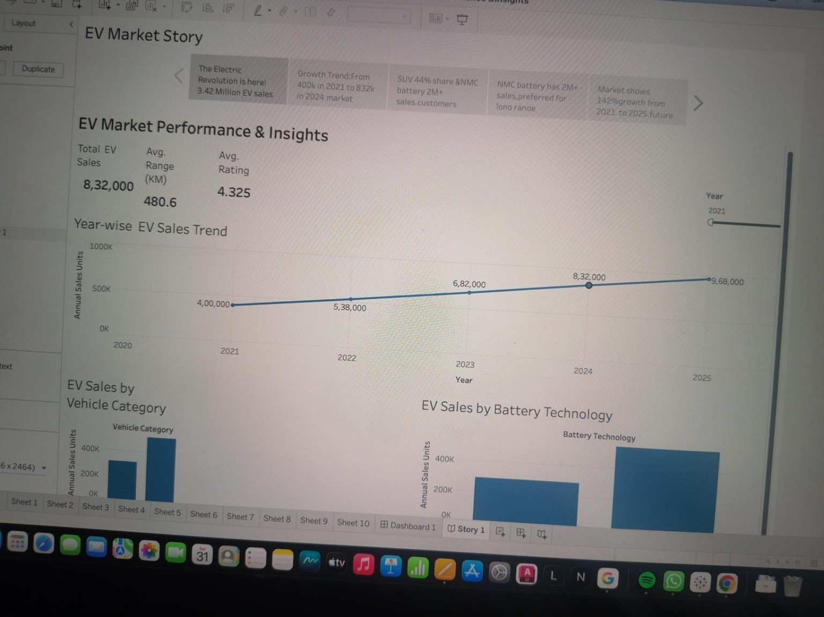

Activity 2 – Publish Dashboard on Tableau Public
Published Tableau Public dashboard / Story link:
https://public.tableau.com/app/profile/joha.khan/viz/EVMarketPerformanceInsights_17930988283380/Story1?publish=yes
Open the link and confirm that it displays the intended published dashboard and Story before submitting.
Validation note: outcomes are transcribed from the supplied screenshots. Verify the workbook's connected CSV and reconcile displayed KPIs with the source dataset.

